Ideation Phase
Define the Problem Statements

Date | 31 January 2025
Team ID | LTVIP2026TMIDS41887
Project Name | visualization tool for electric vehicle charge and range analysis
Maximum Marks | 2 Marks

Customer Problem Statement Template:
Creating a customer problem statement helps us understand the needs and challenges faced by users who interact with electric vehicle (EV) data. This template enables the team to focus on the real concerns of EV users, researchers, and planners by identifying what they are trying to achieve, the barriers they encounter, and the reasons behind those barriers.
A clearly defined customer problem statement allows the team to design an effective EV visualization platform that integrates multiple datasets and presents insights through interactive dashboards and stories. By empathizing with users and understanding how they perceive EV charging and range information, the project aims to deliver meaningful visual analytics that support informed decision-making and improve understanding of EV ecosystems.
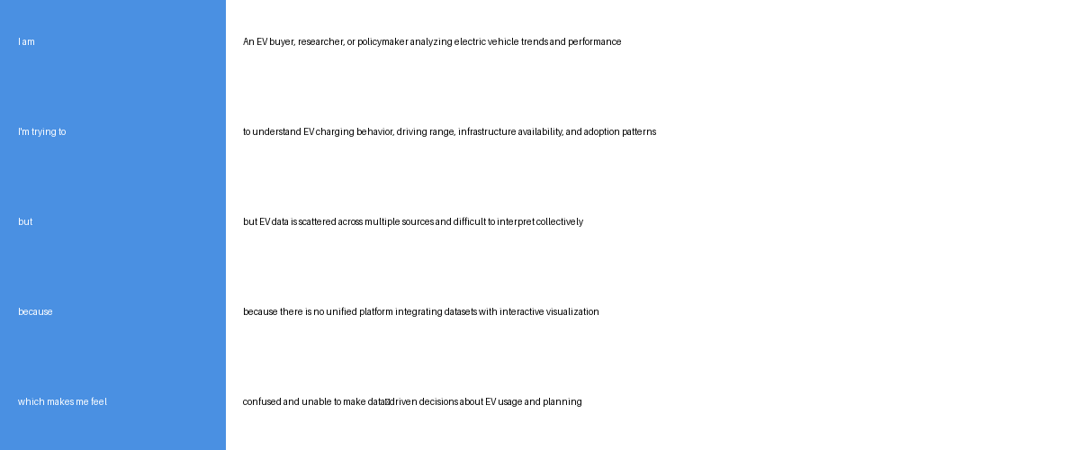

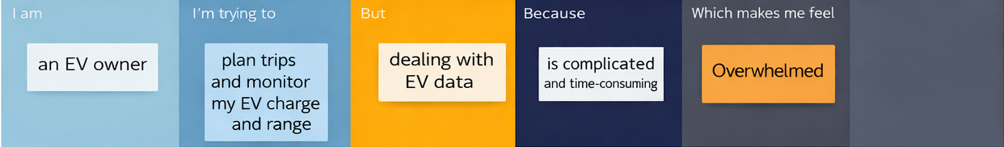
Problem Statement (PS) | I am (Customer) | I’m trying to | But | Because | Which makes me feel
PS-1 | A web user interested in EV performance | Estimate my electric vehicle driving range accurately | It is difficult to manually calculate range under different conditions | EV range depends on battery %, speed, and load variations | Confused and uncertain
PS-2 | An EV owner or researcher | Analyze charge efficiency visually | There is no simple tool to visualize charge vs range easily | Data is scattered and hard to interpret | Frustrated

